**III Exercises**

1)

// or browse Examples

module ReductionOperators();

initial begin

// Bit Wise AND reduction

$display (" & 4'b1001 = %b", (& 4'b1001));

$display (" & 4'bx111 = %b", (& 4'bx111));

$display (" & 4'bz111 = %b", (& 4'bz111));

// Bit Wise NAND reduction

$display (" ~& 4'b1001 = %b", (~& 4'b1001));

$display (" ~& 4'bx001 = %b", (~& 4'bx001));

$display (" ~& 4'bz001 = %b", (~& 4'bz001));

// Bit Wise OR reduction

$display (" | 4'b1001 = %b", (| 4'b1001));

$display (" | 4'bx000 = %b", (| 4'bx000));

$display (" | 4'bz000 = %b", (| 4'bz000));

#10 $finish;

end

endmodule

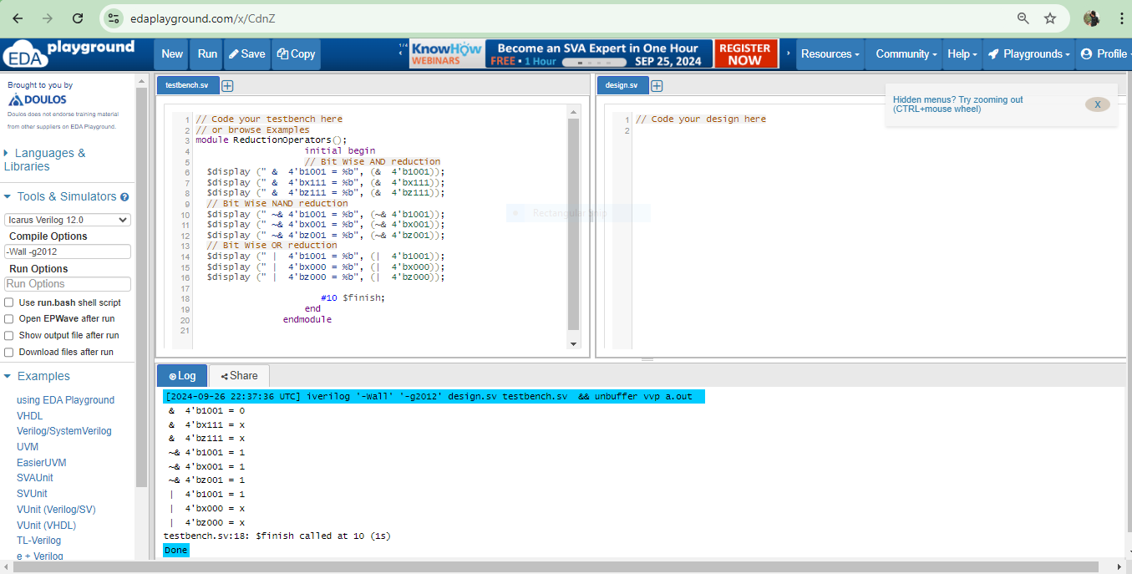

module ShiftOperators();

initial begin

// Left Shift

$display (" 4'b1001 << 1 = %b", (4'b1001 << 1));

$display (" 4'b10x1 << 1 = %b", (4'b10x1 << 1));

$display (" 4'b10z1 << 1 = %b", (4'b10z1 << 1));

// Right Shift

$display (" 4'b1001 >> 1 = %b", (4'b1001 >> 1));

$display (" 4'b10x1 >> 1 = %b", (4'b10x1 >> 1));

$display (" 4'b10z1 >> 1 = %b", (4'b10z1 >> 1));

#10 $finish;

end

endmodule

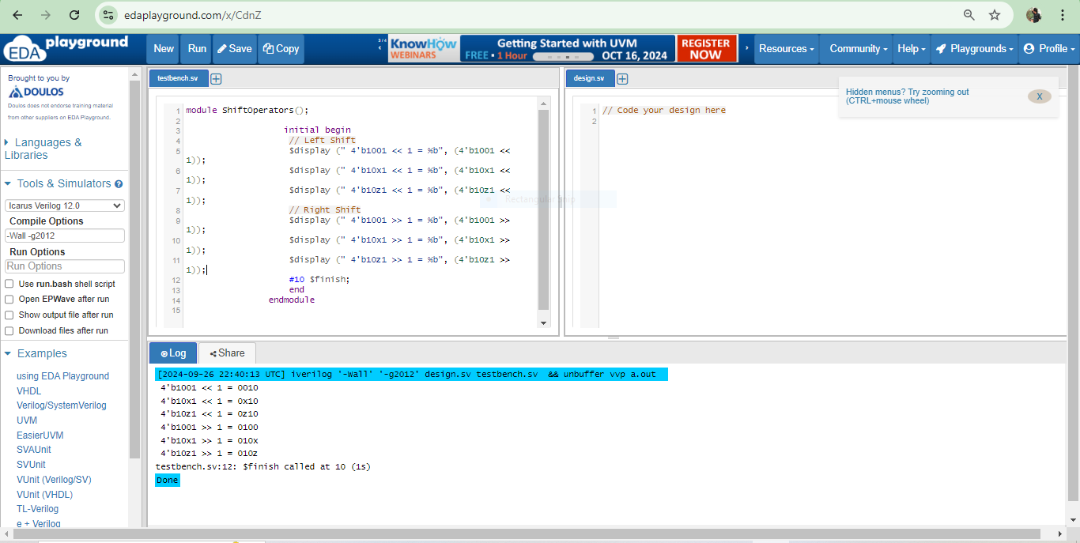

module ConcatenationOperator();

initial begin

// concatenation

$display (" {4'b1001,4'b10x1} = %b",{4'b1001,4'b10x1});

#10 $finish;

end

endmodule

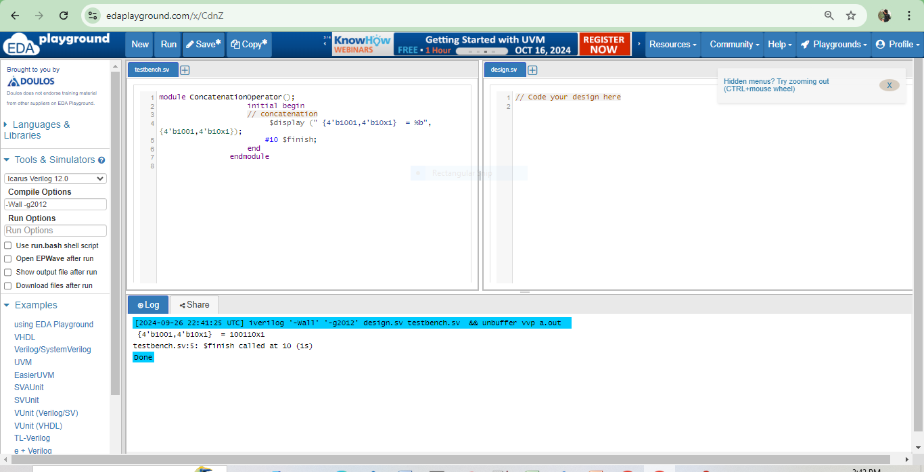

module ReplicationOperator();

initial begin

// replication

$display (" {4{4'b1001}} = %b", {4{4'b1001}});

// replication and concatenation

$display (" {4{4'b1001,1'bz}} = %b", {4{4'b1001,1'bz}});

#10 $finish;

end

endmodule

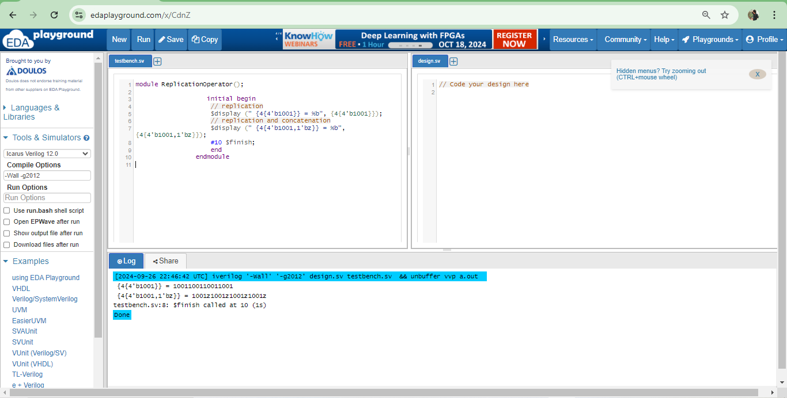

**2)**

//-----------------------------------------------------

`include "addbit.v"

module adder_hier (

result_o, // Output of the // adder

carry_o, // Carry output of // adder

r1_i, // First input

r2_i, // Second input

ci_i // Carry input

);

// Input Port Declarations

input [3:0] r1_i ;

input [3:0] r2_i ;

input ci_i ;

// Output Port Declarations

output [3:0] result_o ;

output carry_o ;

// Port Wires

wire [3:0] r1_i ;

wire [3:0] r2_i ;

wire ci_i ;

wire [3:0] result_o ;

wire carry_o ;

// Internal variables

wire c1_w ;

wire c2_w ;

wire c3_w ;

// Code Starts Here

addbit u0 (r1_i[0],r2_i[0],ci_i,result_o[0],c1_w);

addbit u1 (r1_i[1],r2_i[1],c1_w,result_o[1],c2_w);

addbit u2 (r1_i[2],r2_i[2],c2_w,result_o[2],c3_w);

addbit u3 (r1_i[3],r2_i[3],c3_w,result_o[3],carry_o);

endmodule // End Of Module adder

**module tb();**

reg [3:0] r1_r, r2_r;

reg ci_r;

wire [3:0] result_w;

wire carry_w;

// Drive the inputs

initial begin

r1_r = 0;

r2_r = 0;

ci_r = 0;

#10 r1_r = 10;

#10 r2_r = 2;

#10 ci_r = 1;

#10 $display("+----------------------------+");

$finish;

end

// Connect the lower module

adder_hier U (result_w, carry_w, r1_r, r2_r, ci_r);

// Monitor the results of each adder bit

initial begin

$display("+----------------------------+");

$display("|r1|r2|ci|u0.sum|u1.sum|u2.sum|u3.sum|");

$display("+----------------------------+");

$monitor("|%h |%h |%h |%h |%h |%h |%h |", r1_r, r2_r, ci_r, tb.U.u0.sum_o, tb.U.u1.sum_o, tb.U.u2.sum_o, tb.U.u3.sum_o);

end

endmodule

module addbit (

input a_i, // First input bit

input b_i, // Second input bit

input ci_i, // Carry input

output sum_o, // Sum output

output co_o // Carry output

);

assign sum_o = a_i ^ b_i ^ ci_i; // Sum is XOR of the inputs and carry-in

assign co_o = (a_i & b_i) | (b_i & ci_i) | (ci_i & a_i); // Carry-out calculation

endmodule

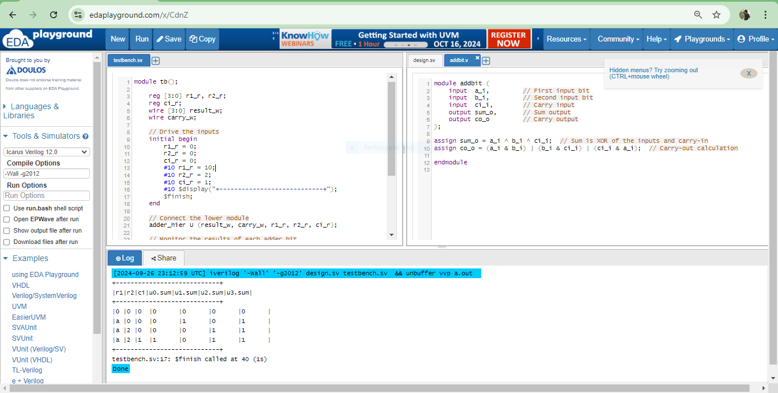

**3)**

Based on the module *adder_hier,* the circuit functional block diagram,

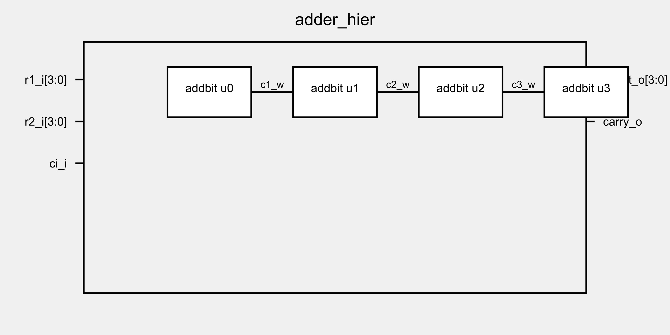

## 4)

## * DFFSynch Module

module DFFSynch(

d_i,

rst_i,

clk_i,

q_o

);

input d_i,rst_i,clk_i;

output q_o;

reg q_o;

always @(posedge clk_i)begin

if(rst_i) q_o <= 0;

else q_o <= d_i;

end

endmodule

//testbr

module tb_DFFSynch;

// Inputs

reg d_i;

reg rst_i;

reg clk_i;

// Outputs

wire q_o;

// Instantiate the design under test (DUT)

DFFSynch dut (

.d_i(d_i),

.rst_i(rst_i),

.clk_i(clk_i),

.q_o(q_o)

);

// Clock generation

initial begin

clk_i = 0;

forever #5 clk_i = ~clk_i; // 10-unit time period clock

end

// Test procedure

initial begin

// Monitor the changes in inputs and outputs

$monitor("clk_i=%b, rst_i=%b, d_i=%b -> q_o=%b", clk_i, rst_i, d_i, q_o);

// Initialize inputs

rst_i = 1; d_i = 0; #10; // Test Case 1: Reset is active, output should be 0

rst_i = 0; d_i = 1; #10; // Test Case 2: Remove reset, d_i=1, output should follow d_i

d_i = 0; #10; // Test Case 3: d_i=0, output should follow d_i

d_i = 1; #10; // Test Case 4: d_i=1, output should follow d_i

rst_i = 1; #10; // Test Case 5: Activate reset, output should go to 0

// End the simulation

$finish;

end

endmodule

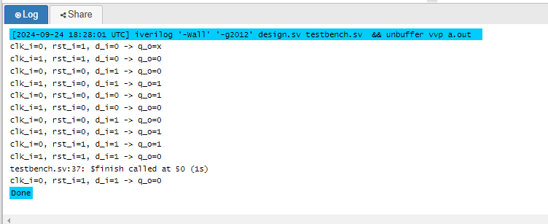

## * DFFAsynch Module

module DFFAsynch(

d_i,

rst_i,

clk_i,

q_o

);

input d_i,rst_i,clk_i;

output q_o;

reg q_o;

always @(posedge clk_i or posedge rst_i)begin

if(rst_i) q_o <= 0;

else q_o <= d_i;

end

endmodule

//tr

module tb_DFFAsynch;

// Inputs

reg d_i;

reg rst_i;

reg clk_i;

// Outputs

wire q_o;

// Instantiate the design under test (DUT)

DFFAsynch dut (

.d_i(d_i),

.rst_i(rst_i),

.clk_i(clk_i),

.q_o(q_o)

);

// Clock generation

initial begin

clk_i = 0;

forever #5 clk_i = ~clk_i; // 10-unit time period clock

end

// Test procedure

initial begin

// Monitor the changes in inputs and outputs

$monitor("clk_i=%b, rst_i=%b, d_i=%b -> q_o=%b", clk_i, rst_i, d_i, q_o);

// Initialize inputs

rst_i = 1; d_i = 0; #10; // Test Case 1: Reset is active, output should be 0

rst_i = 0; d_i = 1; #10; // Test Case 2: Remove reset, d_i=1, output should follow d_i

d_i = 0; #10; // Test Case 3: d_i=0, output should follow d_i

d_i = 1; #10; // Test Case 4: d_i=1, output should follow d_i

rst_i = 1; #10; // Test Case 5: Activate reset, output should go to 0

rst_i = 0; d_i = 1; #10; // Test Case 6: After reset, d_i=1, output should follow d_i

// Add a delay to see the effect of the clock edge

d_i = 0; #10; // Test Case 7: d_i=0, output should follow d_i on next clock edge

#10; // Wait for the clock edge

d_i = 1; #10; // Test Case 8: d_i=1, output should follow d_i on next clock edge

// End the simulation

$finish;

end

endmodule

